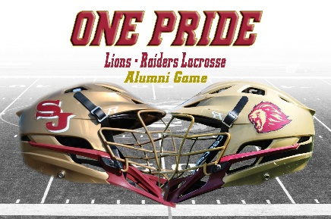

2023 ONE PRIDE ~ Lions - Raiders Lacrosse
Alumni Charity Game
Saturday, June 17, 2023

Waiver, Release, and Covenant Not to Sue Relating to Participation in the Alumni Game
Must be Signed By All Participants

Name of Participant: ______________________________________________ Date of birth:____________

Cell phone: ______________________

In case of emergency, please contact (name and number): ______________________________________

The undersigned acknowledges that I __________________________, am voluntarily participating in the 2023 ONE PRIDE ~ Lions - Raiders Lacrosse Alumni Charity Game (hereafter referred to as “the game”) on June 17, 2023. All activities incidental or related to the game are covered by and agree to the following terms:

- I understand that I will be solely responsible for the actions, conduct and safety of the participant during the activity, including following all rules, regulations, and instructions.
- I understand that there are certain risks inherent in participation in game and the activities incidental or related thereto.
- I knowingly and voluntarily assume the risk of injury, illness, or other harm due to any act, event, or omission related to my participation.
- I understand that participation of the participant is entirely voluntary.
- I understand that this is a private event that is not a Unity Reed High School or Prince William County Schools sponsored event.
- I release, discharge, covenant not to sue, indemnify, hold harmless, and absolve Unity Reed High School/Prince William County Schools, its officers, boosters, volunteers and event organizers from and against any and all injuries, disability, death, property damage, or any loss, damages, or expenses by or behalf of the participant arising form or in any manner related to the game.

I HAVE CAREFULLY READ THIS AGREEMENT AND FULLY UNDERSTAND ITS CONTENTS. I AM AWARE THAT THIS AGREEMENT INCLUDES A WAIVER OR LIABILITY AND RELEASE, AN ASSUMPTION OF RISK, AND AN AGREEMENT BY ME TO IDENMIFY THE RELEASES AND I SIGN IT OF MY OWN FREE WILL.

Print Name of Participant: ____________________________ Date: _____________________

Signature of Participant: _______________________________________________________

