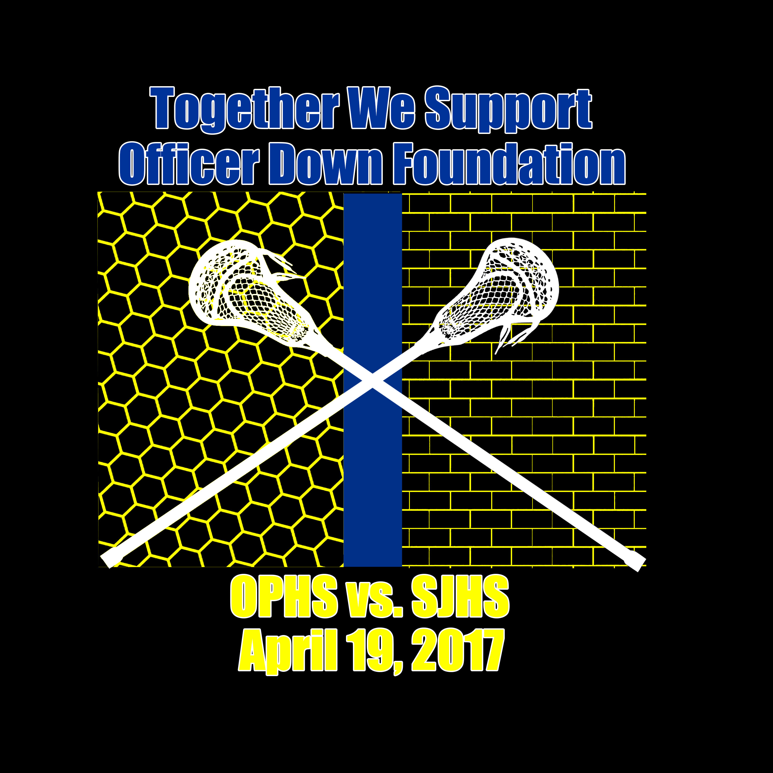
Fundraiser for the Officer Down Foundation
Shirts are $25 (all profit will go to the Officer Down Foundation)
Orders must be received by Sunday April 9th for delivery at the game (4/19)!
Name: __________________________________________________
Phone #: ________________________________________________
Size Shirt(s): ______________________________________________
Total: $___________________________________________________
Available sizes: (Adult)
S M L XL
XXL($3 extra) XXXL ($3 extra)
Orders: Email nancy@thetebells.com or call 703-851-8506 (OPHS)
SJHS Contact: Stephanie LeClair leopardes32@aol.com or call 703-785-8838

Make Checks Payable to: OPHS ABC (money can be collect that night)

